DSI lecture 30 visualization 5

Overview of the slide deck (advocacy):
- Explore examples and ideas behind data visualization as used for advocacy
- Discuss how, through form, representation and credit, we can put advocacy into practice with our own data visualization.
Data visualization for advocacy
- We encountered several examples of data visualization for advocacy so far including nightingales diagram, the US gun killings diagram
  - Each of these examples is a case of data visualization being used in support of some call or goal (advocacy)
    - Understanding the logic behind data visualization for advocacy is useful whether we want to use data to advocate for a cause or to critically engage with data visualizations used by advocacy groups
3 elements of persuasion
- Data visualization is inherently rhetorical and we have 3 types of persuasion:
  - Rational appear: giving people access to facts will let them make the right conclusion
  - Moral appeal: appealing to moral values and ethical convictions
  - Emotional appeal: producing and exploiting emotional reactions
Example
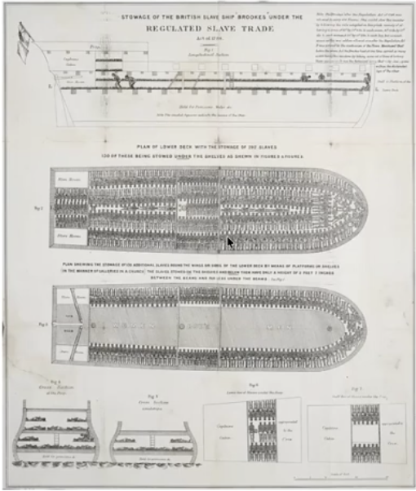
- Slave trade boat diagram
  - Seemed to make an instantaneous impression of horror on those who saw it supporting demands for abolition
- Different visual same message
  - At the same time of this diagram people printed slogans and art on dishware intended to provoke outrage and in turn action to abolition
Two functions of data visualization for advocacy
- Presentation: describing and depicting the facts
- Representation: subjectively depicting ideas using metaphor, analogy, and allegory
  - Most visuals for advocacy use both, but we should understand them as distinct elements so we can tell apart the extent to which visualizations use each
Data visualization as advocacy
- Form: what can data visualization be?
  - So far the examples we have seen are in print or digital images but there can be non traditional forms including the media, videos, art works, interactive art
- Representation: what data are we seeing?
  - Remember data visualizations are rhetorical because in making them we make choices about how to select and represent aspects of reality
    - A major aspect of this choice is choosing which data to collect and translate into visual form
    - Just as important is the data we don’t see
  - The way we collect data impact and limit the ways we can later visualize those data
    - For example a binary gender variable means excluding nonbinary identities
    - Maternal mortality data are collected from all over the world but data on other aspects of womens lives are overlooked
  - Data defined broadly can include: words or stories, colors or sounds, or any type of information that is systematically collected, organized and analyzed
  - When visualizing data we should question the ways our work incorporates or excludes less conventional kinds of data including stories, artwork, testimonials of lived experience and the way these exclusions can enforce existing power structures
- Credit: data visualization as the tip of the iceberg
- 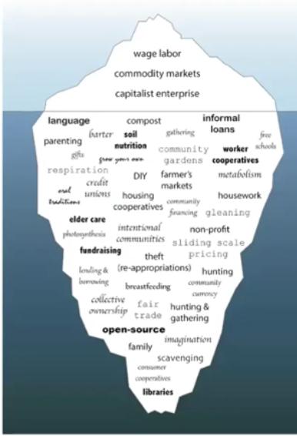
  - The diverse economies iceberg displays the idea of underwater labour or the idea of work such as caregiving or domestic labour as essential to wage labour but often unacknowledged
  - This artowrks relates the idea of underwater labour to data visualizations
    - How many unseen contributions does it take for visualization to exist in its final form:
      - Think of:
        - Community organizers facilitation data collection
        - Designers creating color pallets for visualization
        - Technical writers
        - Student Ras
        - IT support staff
        - Caregivers for peoples children
  - Data visualization is the product of a particular data setting and of the work people do within that setting
    - By crediting all contributors we can make the underwater labour of data visualization visible and valued
Next:
- Building on matplotlib basics to explore other libraries for dataviz in python
  - Seaborn
  - Interactive viz
  - Maps
  - Wordclouds/diagrams
- Seaborn
  - Load dataset from seaborn using
    - Sns.load_dataset('dataset_name’)
  - To make a simple lineplot
    - sns.lineplot(data= data_set,
    - x = 'column_name',
    - y = 'column_name’)
  - Using premade styles
    - Sns.set_style(‘style_name’)
      - *this goes before the plot
  - Adding title and axis labels
    - Graph_name.set(title=’title’,
      - Xlabel = ‘label’,
      - Ylabel = ‘label’
        - *we have to save the graph as a variable first before applying
  - Modifying aesthetic elements
    - graph = sns.lineplot(data= tips,
    - x = 'total_bill',
    - y = 'tip',
    - color = 'hotpink',
    - linestyle = '--',
    - linewidth = 3,
    - marker = 'o',
    - markerfacecolor = 'indigo')
    - Basically we just add customization elements after we define the graph like in matplotlib
But why is seaborn an improvement? (code)
- Seaborn lets us visualize multiple variables with different visual elements of our graph
  - graph2 = sns.scatterplot(data = tips,
  - x = 'total_bill',
  - y = 'tip',
  - style = 'time',
  - hue = 'day',
  - palette= ['purple', 'hotpink', 'deepskyblue', 'yellowgreen'])
  - graph2.set(title= 'tips vs total bill',
  - xlabel = 'total bill',
  - ylabel = 'tip amount')
  - So here hue and style are the 3rd and fourth variables
    - Hue is the color of our datapoints
    - Style is the style of our datapoints
      - Palette lets us specify different colors for different levels of hue
- This is a lot harder to do in matplotlib
  - We’d have to split the whole dataset into 8 groups and plot the datasets separately using different markershapes and colors
Pairplot in seaborn
- Pairplot is another convient way to compare variables
  - This plots all quantitative variables on each other using the appropriate graphs (histogram for itself and scatter plot) like so:
      - sns.pairplot(data = tips)
- we can also specify hue and style to plot addition categorical variables
    - sns.pairplot(data = tips,
    - hue = 'day')
- These pairplots can be used to support analysis to better get a sense of the dataset as a form of exploratory analysis
Replot in seaborn
- Replot help us make comparisons between specific levels within variables

